Name _____________________________ |  |  | Date ___________________
Direction
Use the following map to fill in the blanks. 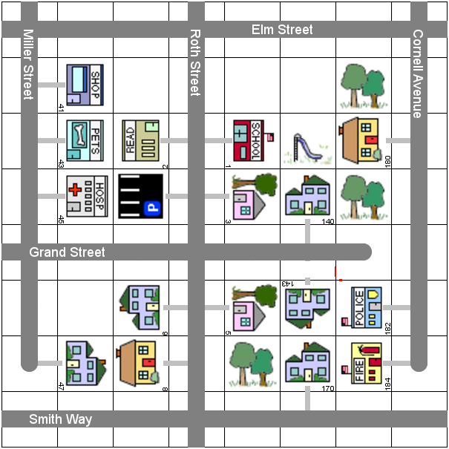

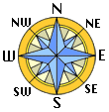

Name _____________________________ |  |  | Date ___________________
Direction
Fill in the blanks with north, south, east, or west.
1. Smith Way is ______________ of Grand Street | 2. Go ______________ to drive from the house at 6 Roth Street to the school at 1 Roth Street .
3. Elm Street is ______________ of Smith Way | 4. Go ______________ to drive from the house at 180 Cornell Avenue to the fire station at 184 Cornell Avenue .
5. Miller Street is ______________ of Roth Street | 6. Cornell Avenue is ______________ of Miller Street
7. Go ______________ to drive from the hospital at 45 Miller Street to the house at 47 Miller Street . | 8. Roth Street is ______________ of Cornell Avenue
9. Go ______________ to drive from the pet shop at 43 Miller Street to the hospital at 45 Miller Street . | 10. Go ______________ to drive from the police station at 182 Cornell Avenue to the fire station at 184 Cornell Avenue .

